**PROJECT 6 - ANALOG AND DIGITAL TIMER**

**1. Your C, C++, or Python program, with comments.**

Ans:

Python Program:

import RPi.GPIO as GPIO #importing GPIO library

import time

led = [5,6,13,19,26]

servo_pin=12

button1=20

button2=21

GPIO.setmode(GPIO.BCM)

GPIO.setup(led[0], GPIO.OUT)

GPIO.setup(led[1], GPIO.OUT)

GPIO.setup(led[2], GPIO.OUT)

GPIO.setup(led[3], GPIO.OUT)

GPIO.setup(led[4], GPIO.OUT)

GPIO.setup(servo_pin, GPIO.OUT)

GPIO.setup(button1, GPIO.IN)

GPIO.setup(button2, GPIO.IN)

GPIO.output(led[0], 0)

GPIO.output(led[1], 0)

GPIO.output(led[2], 0)

GPIO.output(led[3], 0)

GPIO.output(led[4], 0)

GPIO.output(servo_pin, 0)

pwm=GPIO.PWM(servo_pin, 50)

check=0

def setAngle(angle):

duty = angle / 36 + 3

pwm.ChangeDutyCycle(duty)

def tmr():

print("Timer Started")

print("Press Button 2 to reset")

pwm.start(0)

angle_value=0

while True:

if check==0:

break

for j in range(0,6):

for i in range(0,361,6):

angle_value+=i

setAngle(angle_value)

time.sleep(1)

if (GPIO.input(button2) == 1):

check=0

pwm.stop()

print("Timer Ended")

break

if check==0:

break

if j<5:

GPIO.output(led[j], 1)

elif j==5:

for k in range(0,5):

GPIO.output(led[k], 0)

try:

print("Program Started")

while True:

if check == 0:

print("Press Button 1 to start")

print("Enter Ctrl+c to close")

check=1

if (GPIO.input(button1) == 1):

tmr()

except KeyboardInterrupt:

print("Program Closed")

GPIO.cleanup()

exit()

**2. Wiring diagram of your circuits.**

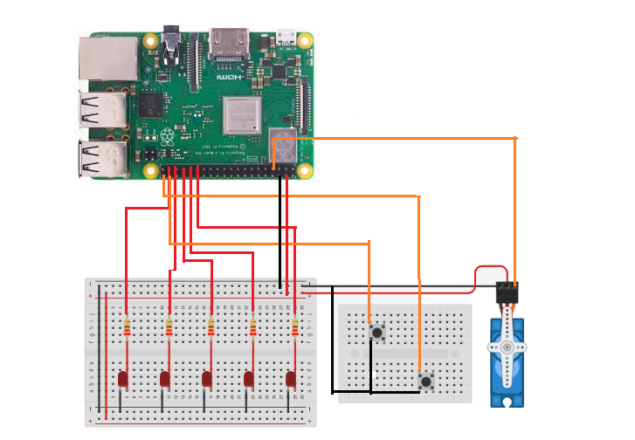

**3. Picture of your circuits.**

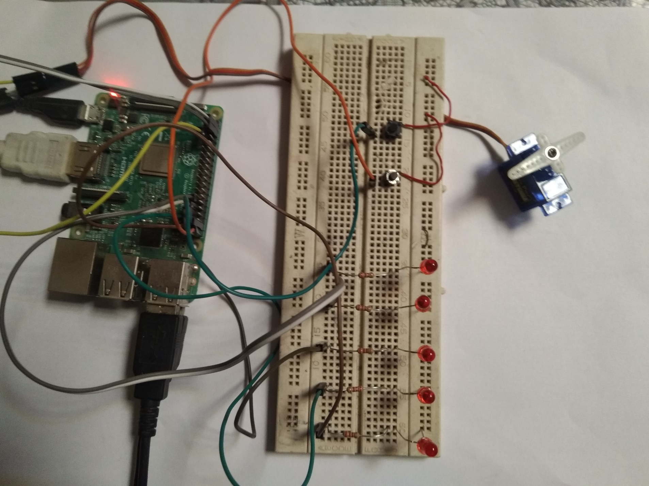

**4. Video demo of your project working. A URL link to your video can be placed in the document. Make**

**sure, to set the permissions on your video file so that it can be viewed by anyone with the link.**

**Ans:**

https://youtu.be/v64eie8To9Y

**5. Describe your approach to this project. List any problems that you’ve encountered and how you**

**overcame these issues.**

**Ans:**

In this project we have to run the servo motor as a timer. The components we need are five leds, aa servo motor, jumper wires and two push buttons .one for start and one for resetting the circuit program. First of all, we will connect the circuit. The five leds are connected with the five GPIO pins of the raspberry pi along with the resistor. Two push buttons are also connected with the other two GPIO pins of the Raspberry pi. While the PWM pin of the servo motor is connected to one of the allocated GPIO pins. After making circuit now we have to program this. In first step we run the servo motor as seconds needle of the clock. We start the loop with the iteration of 1 second in and it run from 0 to 59 making total of 60 seconds.

After each successful completion of 60 second one led will be ON and similarly when the circuit complete 5 cycles of the 60 seconds then all the leds are ON at the end of completion. This in programming is done by adding break after every cycle and turn the led ON. In this way when each cycle completed the program flow break the process of 60 seconds servo motor rotation and turn ON the led. After the led ON the circuit come back to its previous state and again start rotation of servo motor till the servo motor reaches at the angle of 60 degree in 60 seconds.

The second push button is used to start the program from the beginning. This push button turns OFF all the leds and reset the servo motor in its start position that is angle 0 degree and then after completing this the program again start. Again, starting of program repeat the same process.